Name: Miss Mahlatse Mabitsela

Student number: 2805001825

Date: 24 May 2026

The below information provides actionable insights into retail sales performance using transaction-level data.

Column Descriptions of the data set
- Transaction ID (bigint) Unique identifier for each individual transaction in the dataset, with 1,000 distinct values representing each purchase event.
- Date (date) The date when the transaction occurred, spanning 345 unique dates and enabling time-series analysis of sales trends and seasonality.
- Customer ID (string) Unique identifier for each customer, with 1,000 distinct customers indicating one transaction per customer in this dataset.
- Gender (string) Customer's gender classification with two categories (Male, Female) used for demographic segmentation and gender-based purchasing pattern analysis.
- Age (bigint) Customer's age in years, ranging from 18 to 64 with an average of 41.4 years, used for age cohort analysis and demographic profiling.
- Product Category (string) The category of product purchased with three distinct values (Electronics, Clothing, Beauty) for product line performance analysis and category comparison.
- Quantity (bigint) Number of units purchased in the transaction, ranging from 1 to 4 units with an average of 2.5, indicating typical purchase volume per transaction.
- Price per Unit (bigint) The price of a single unit of the product in dollars, ranging from $25 to $500 with an average of $179.89, reflecting product pricing across categories.
- Total Amount (bigint) The total transaction value in dollars (Quantity × Price per Unit), ranging from $25 to $2,000 with an average of $456, representing the revenue generated per transaction.

Step 1

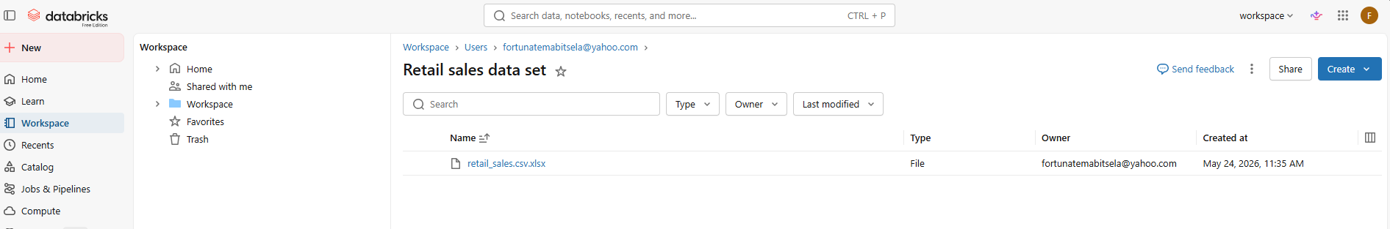

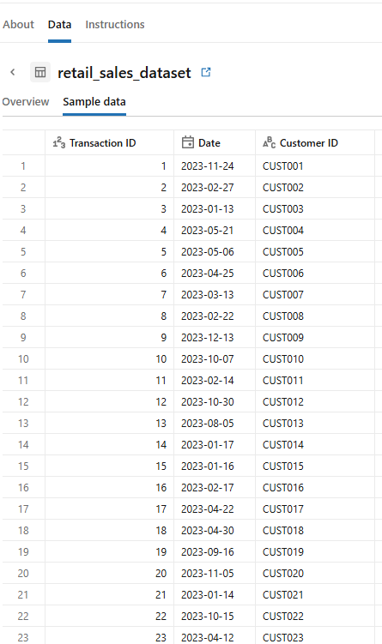

Step 2
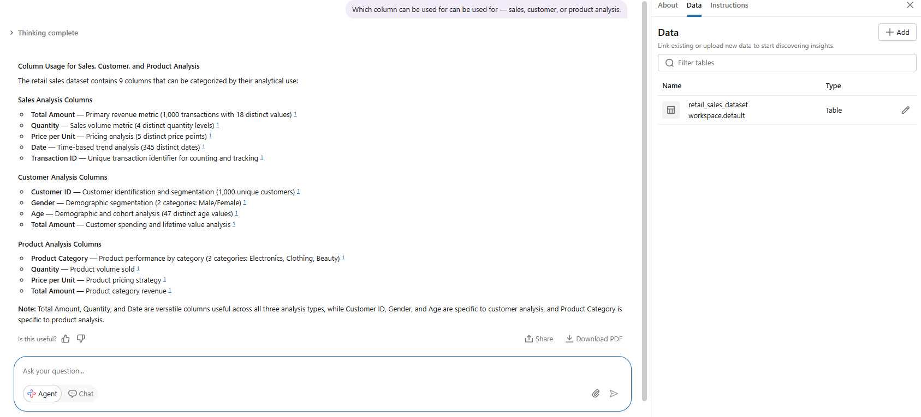
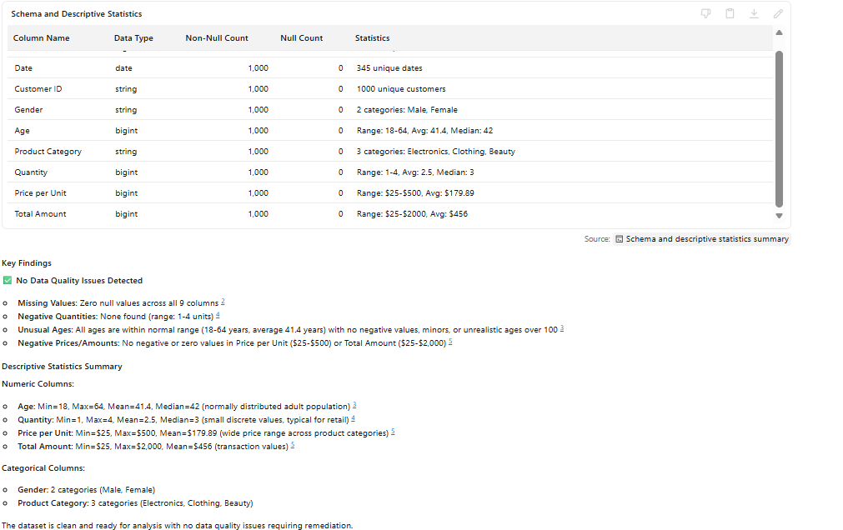

Step 3
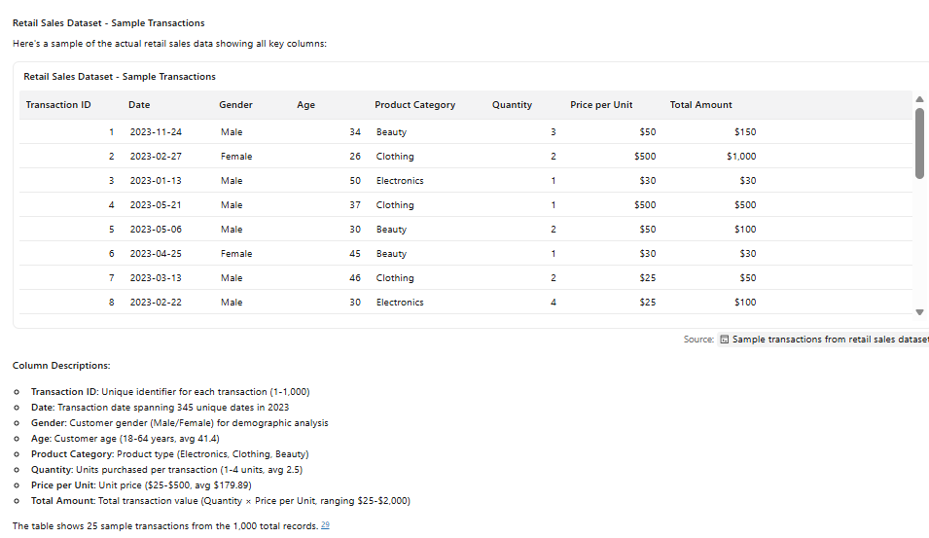
Step 4
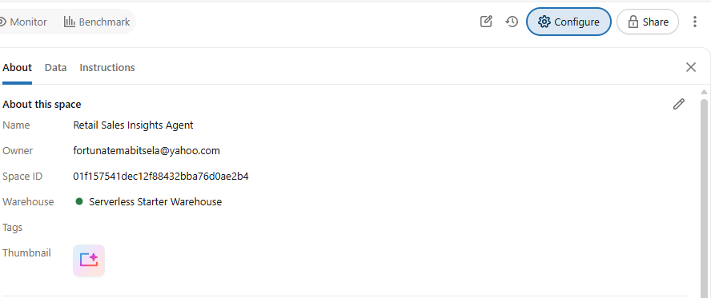

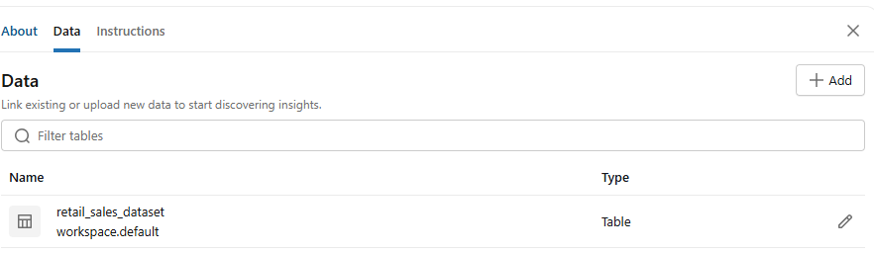
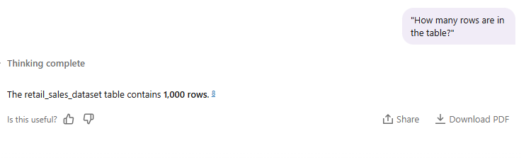
Step 5
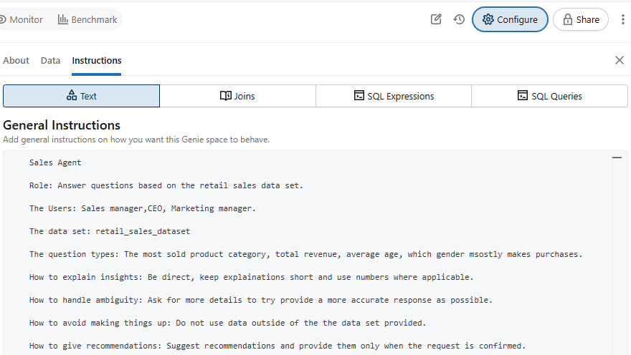
Step 6: Test with 10 questions
Q1
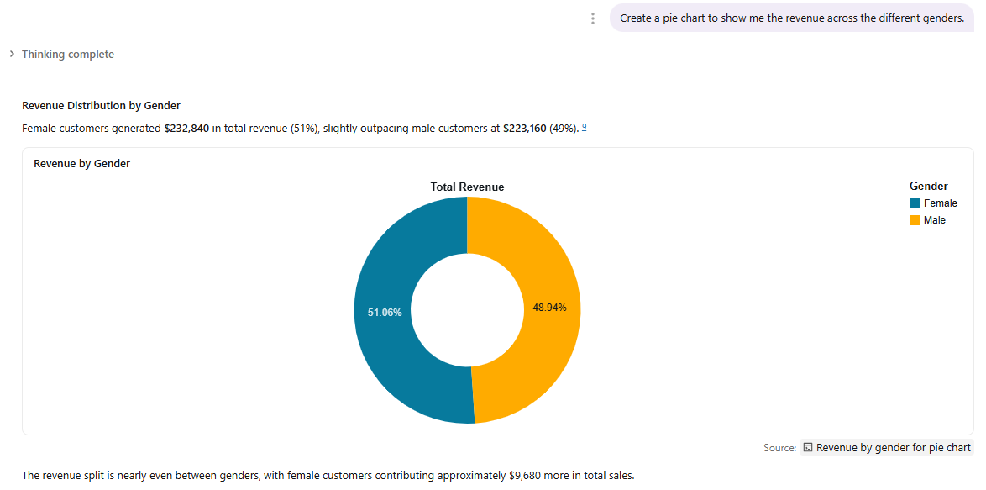
Q2
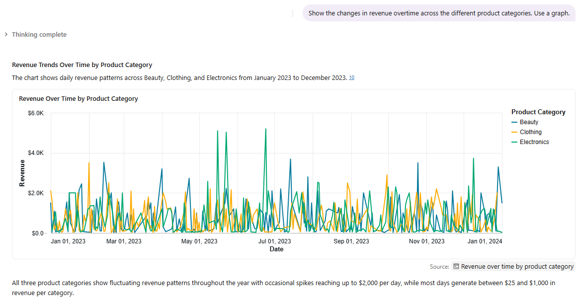

Q3

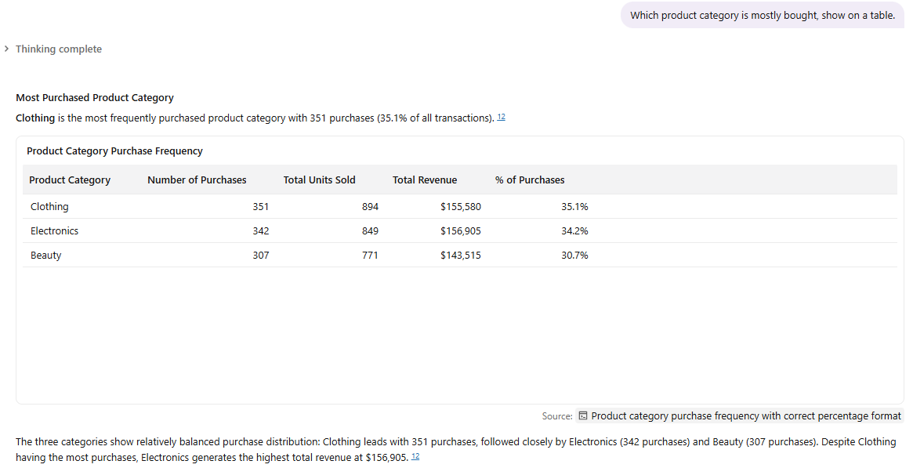

Q4
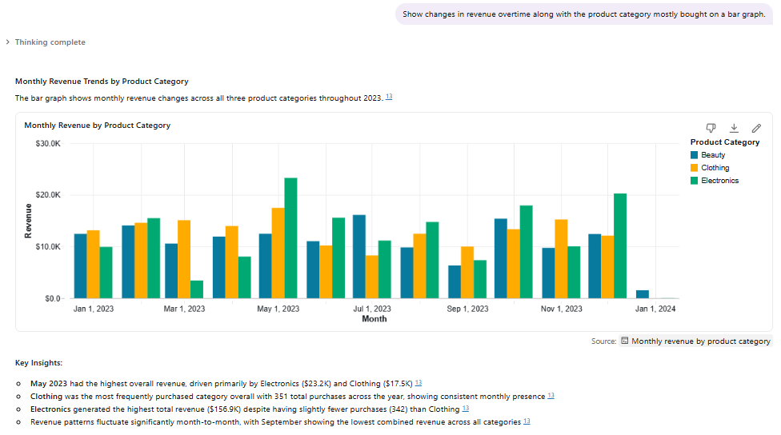

Q5
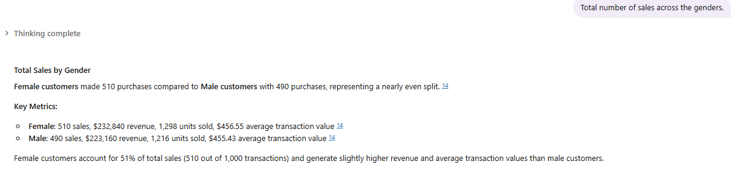
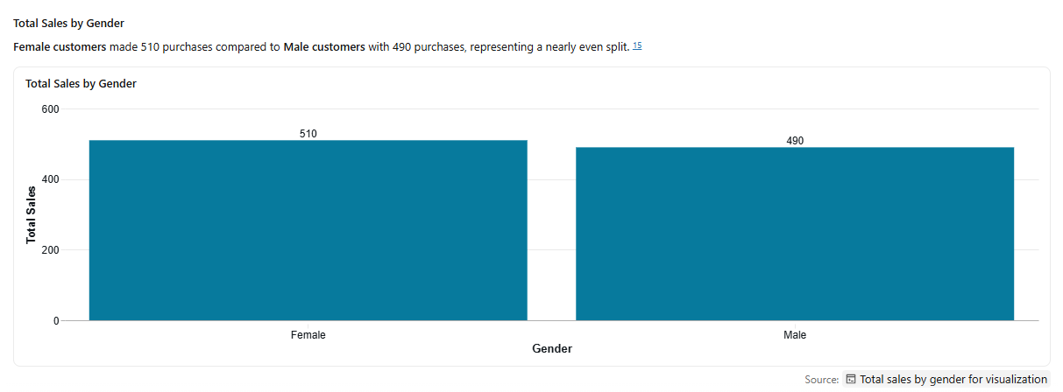

Q6
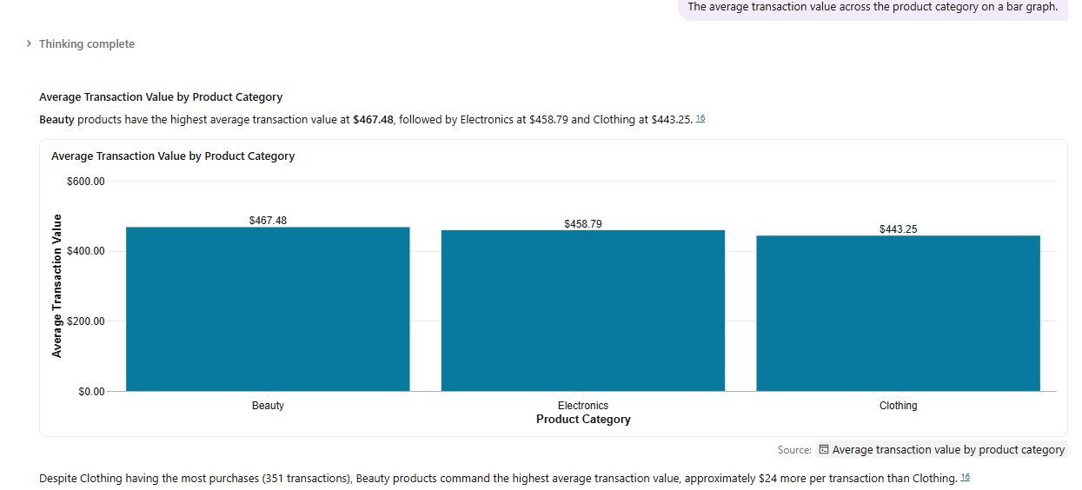

Q7
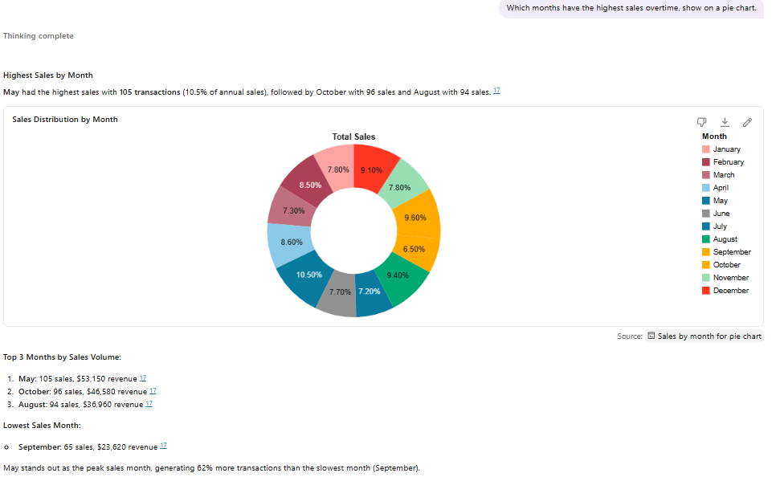

Q8
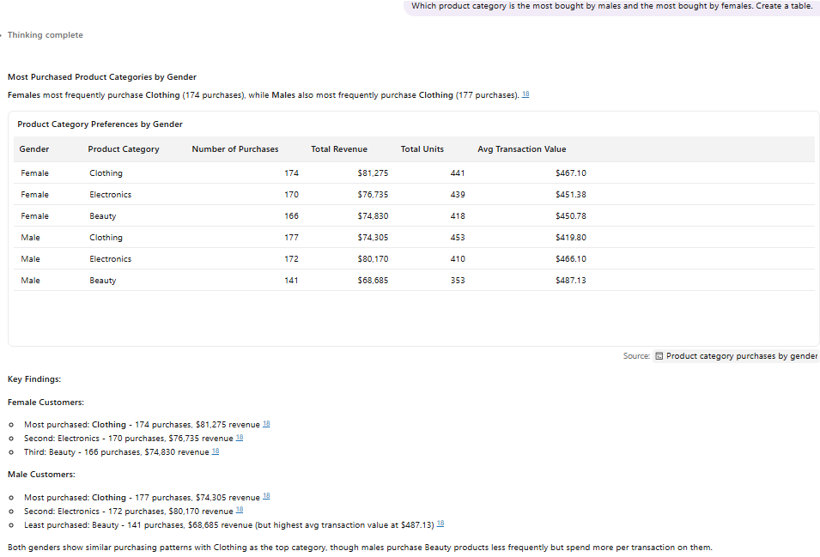

Q9
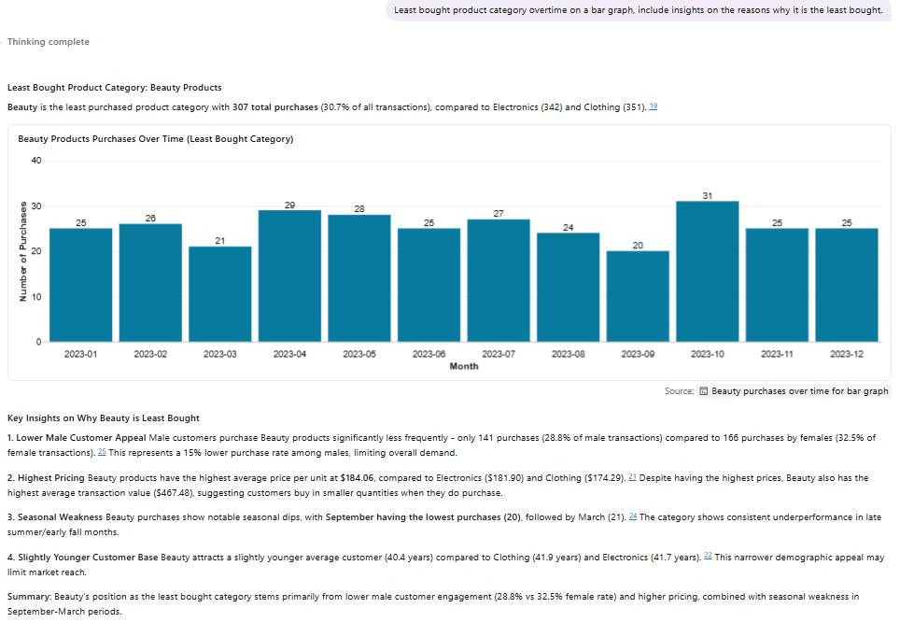

Q10

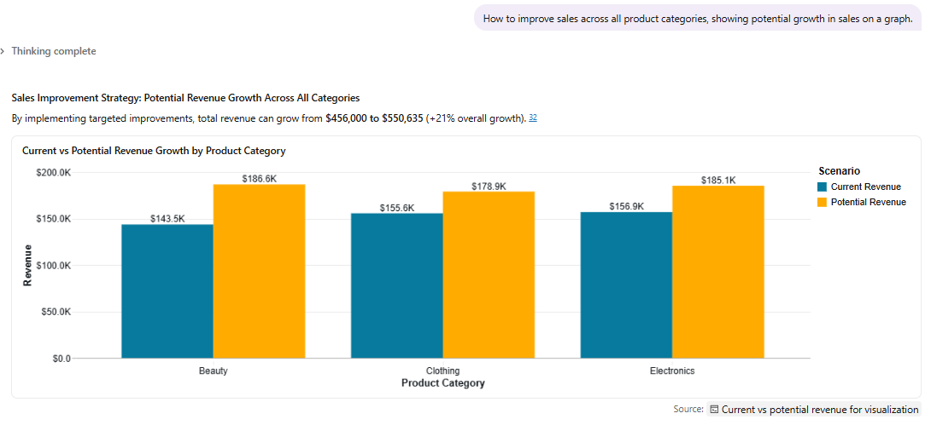
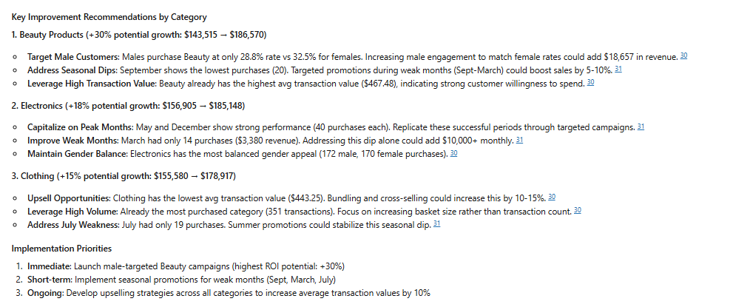

Step 7: Answer validation
Initial answer:
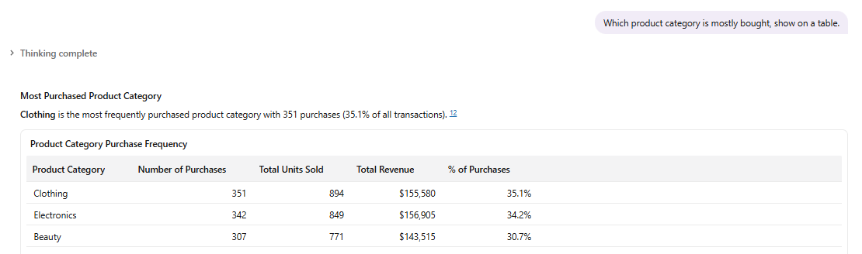

SQL query answer:
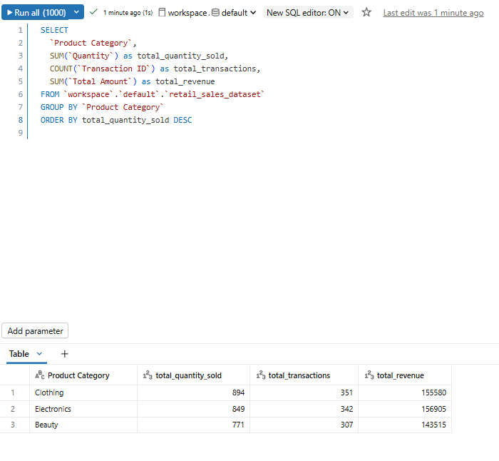
Initial answer:
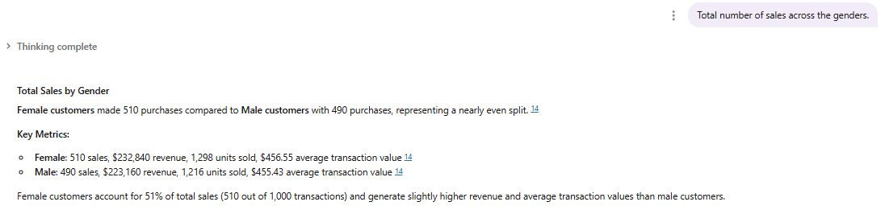

SQL query answer:
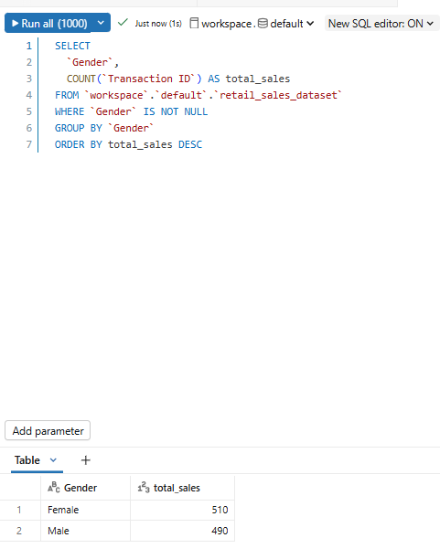

Initial answer:
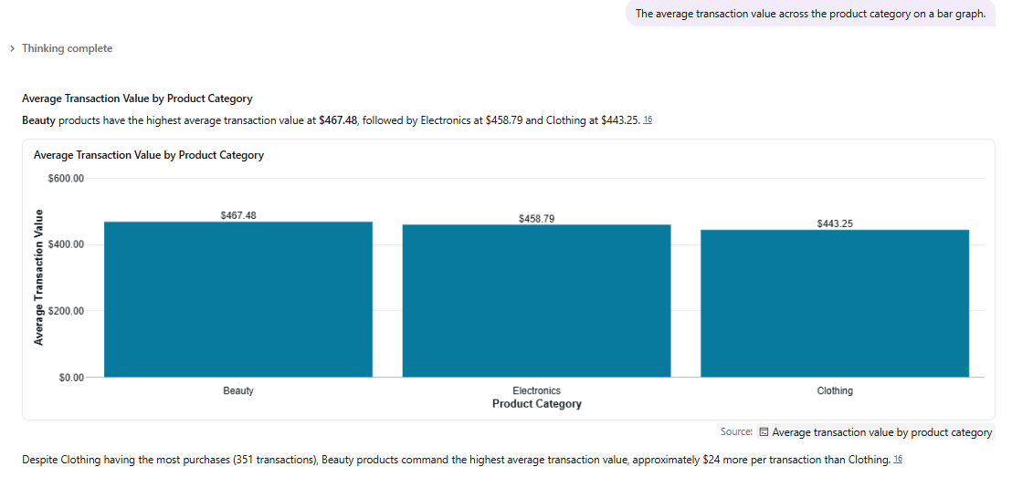
SQL query answer:
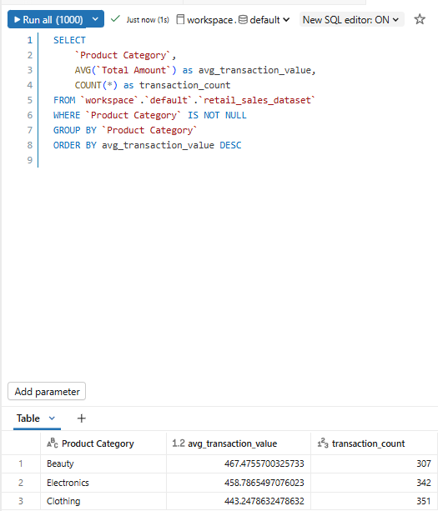

Github link: https://github.com/HlatseM/Data-Agent-exercise

